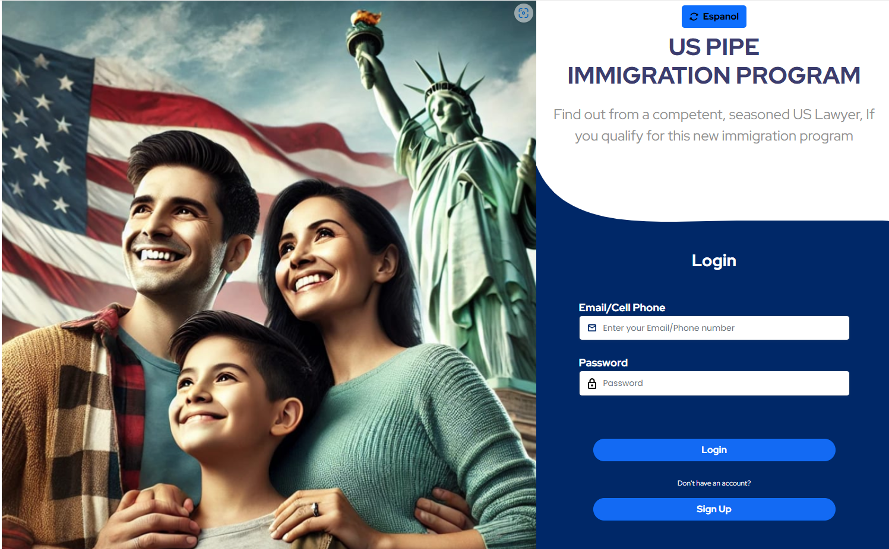

1. Most of our clients only speak Spanish, so the default needs to deploy in Spanish. However, we develop everything in English first so you’re comfortable. And then making sure the Español button works.
2. The Español button needs to be more very visible.
3. Need a (?) by Email/Cell Phone, explaining the accepted formats. E.g., the default cell is +1, but if the cell is foreign, do we need a + in front of it or not? +52 for Mexico country code, or just 52.
4. (?) by Password, simple rules.
5. We’ll need to send the 6-digit code via email or a text to the person. I’ll purchase the SMS service today, what do you recommend?
6. A lot of our clients are computer-challenge, we should add a message of where to call or email.